2 Sorting on 4 different Arrays

Assignment 3: Benchmark on sorting time

1. Observations

|  |  |  |
| --- | --- | --- |
|  | Selection Sorting | Insertion Sorting |
| Ordered Arrays |  | Better choice |
| Reversed Arrays | Better choice |  |
| Random Arrays | Similar performance | |
| Partially-ordered Arrays |  | Better choice |

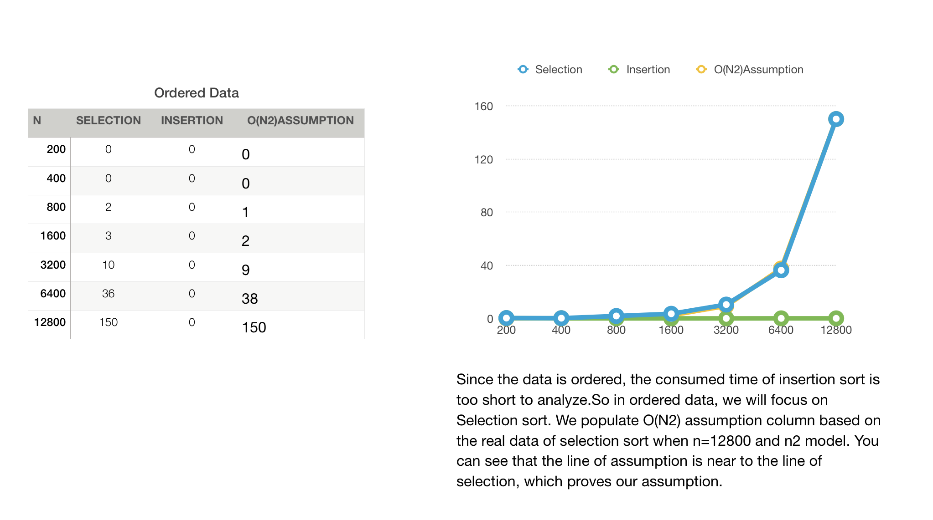Ordered Data:

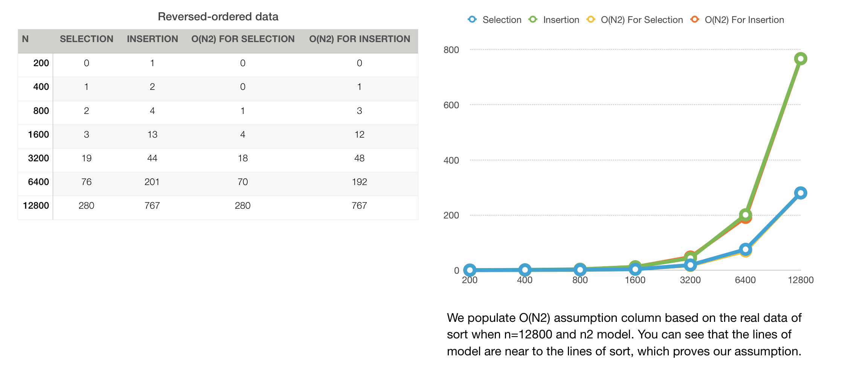Reversed-ordered Data:

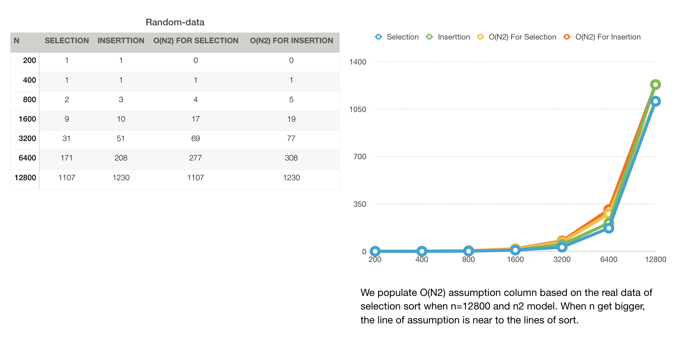Random Data:

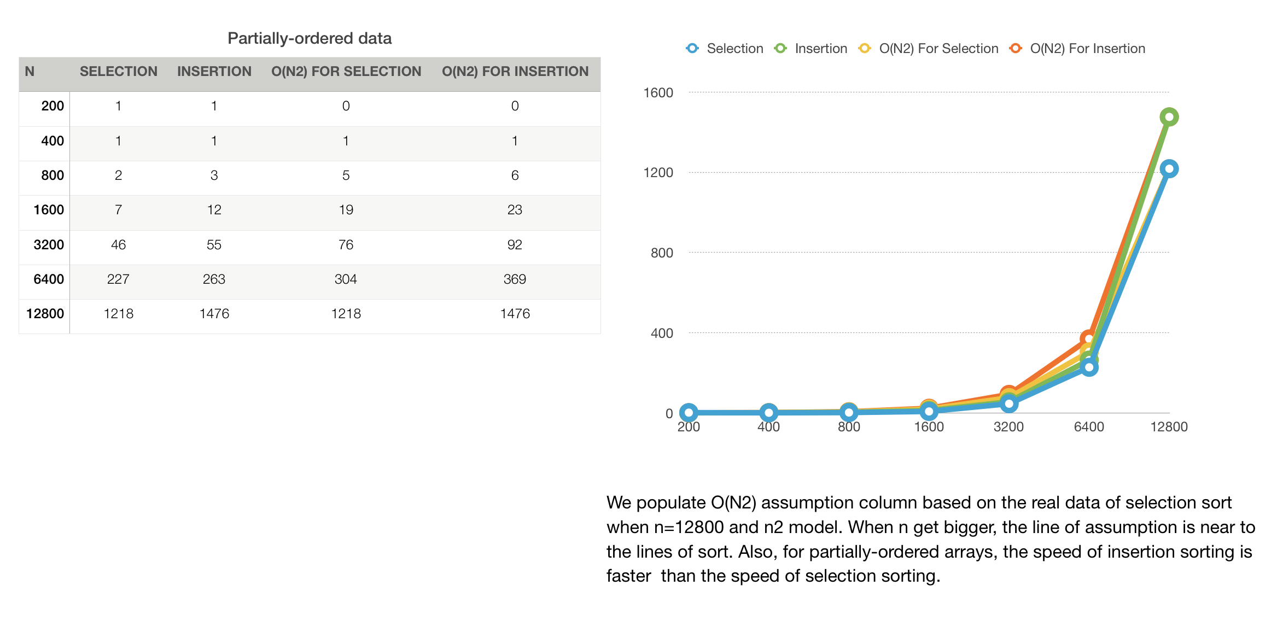Partially-ordered Data

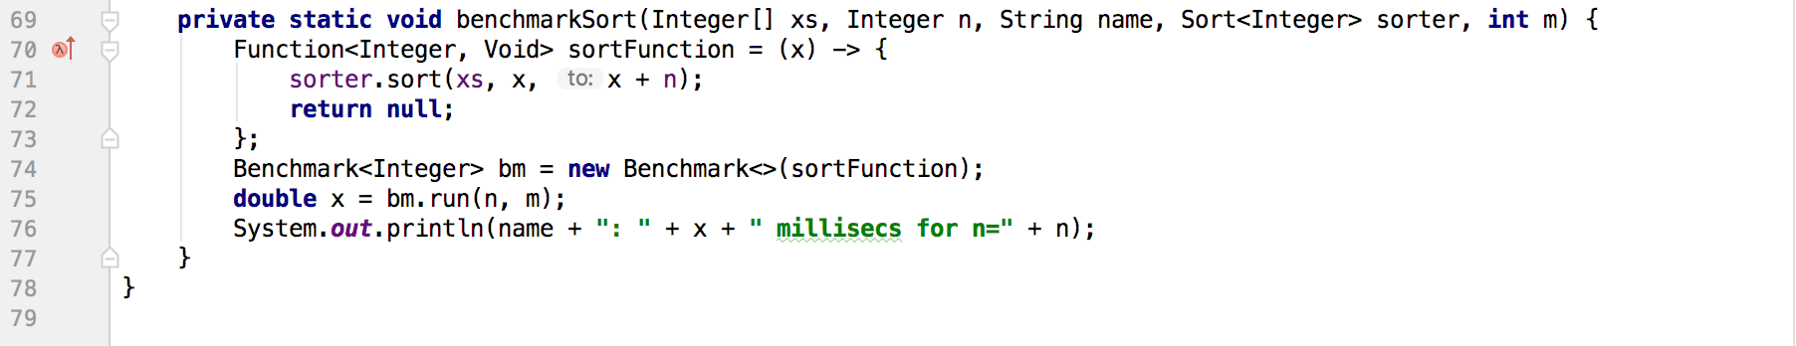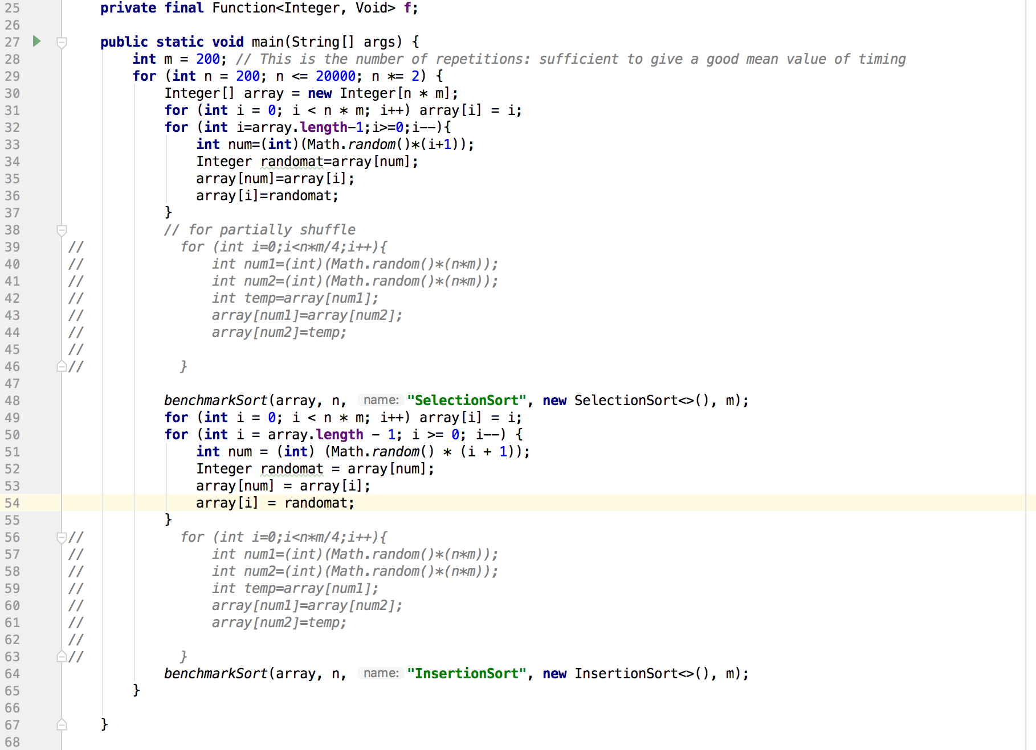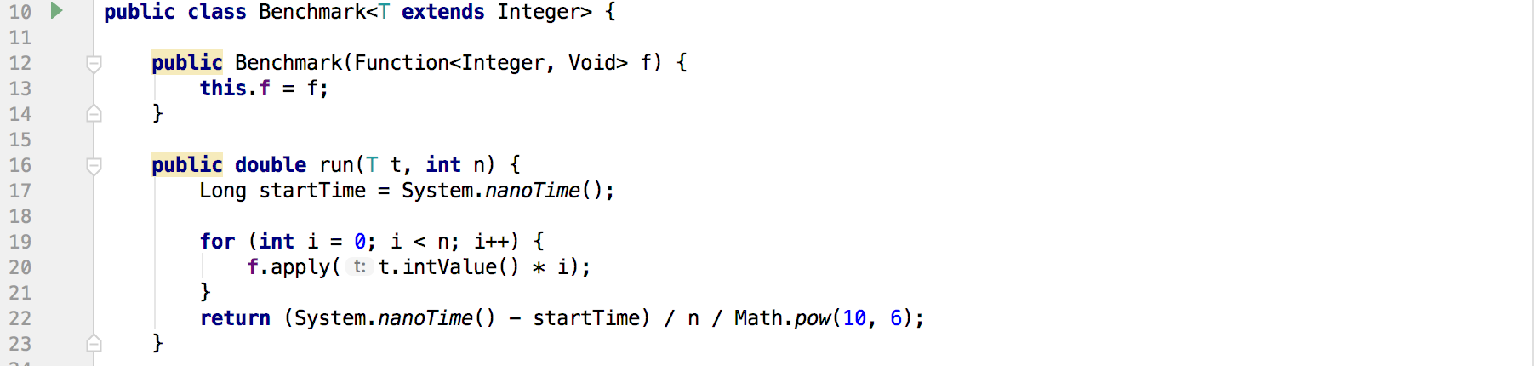II. Screen shots of code and results

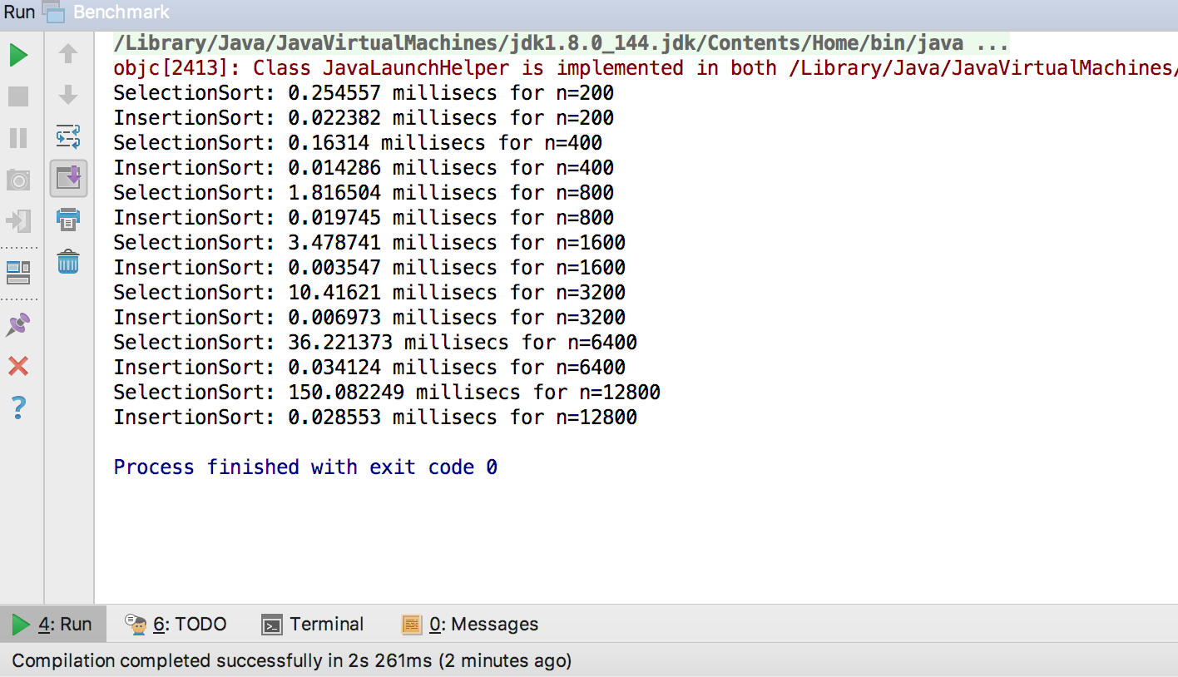Ordered Data

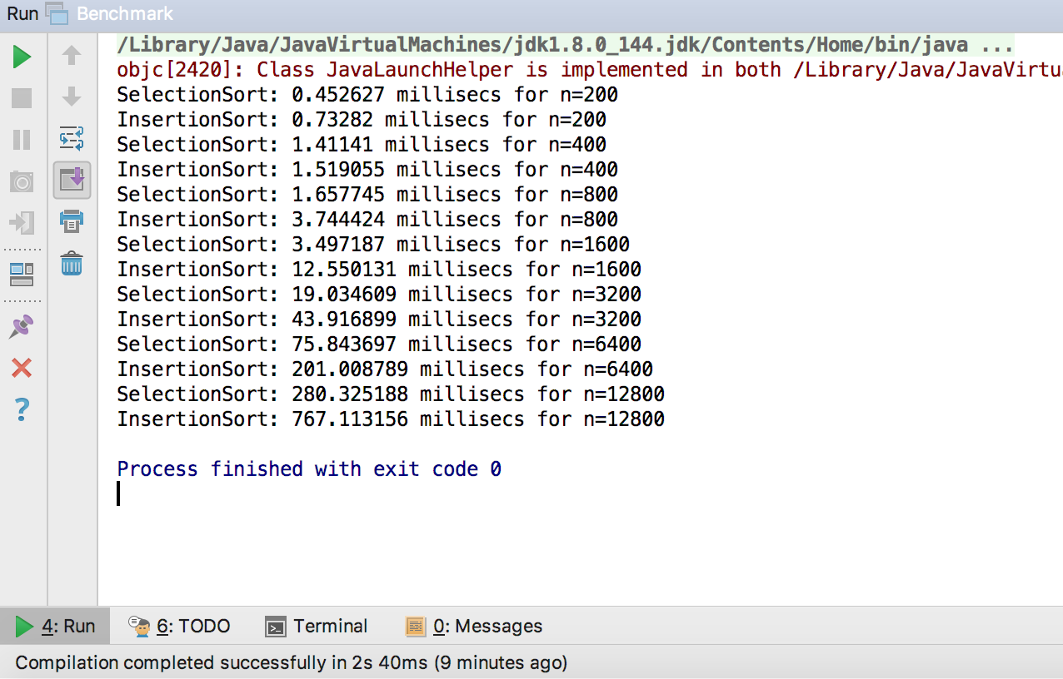Reversed Data

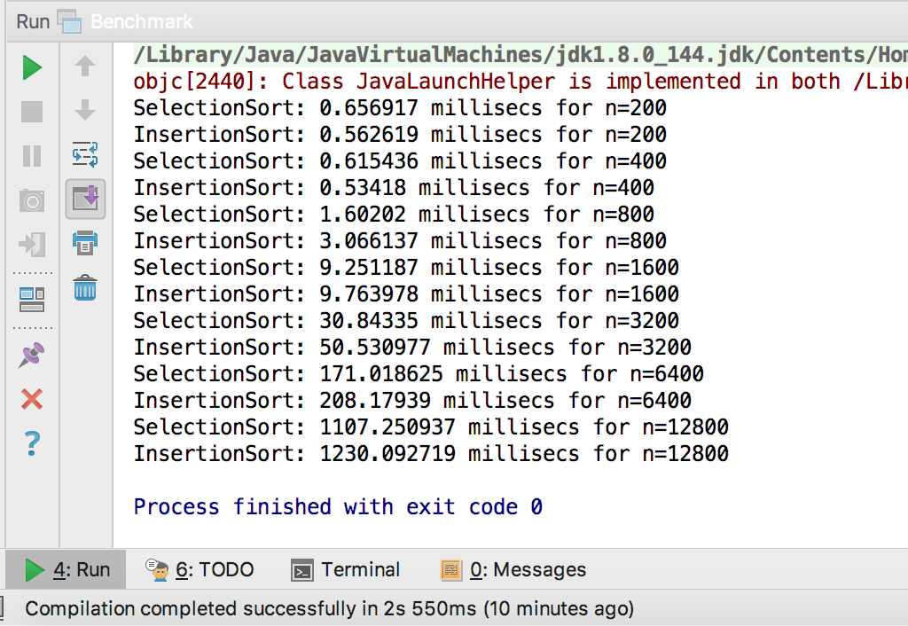Random Data

Partially-ordered Data

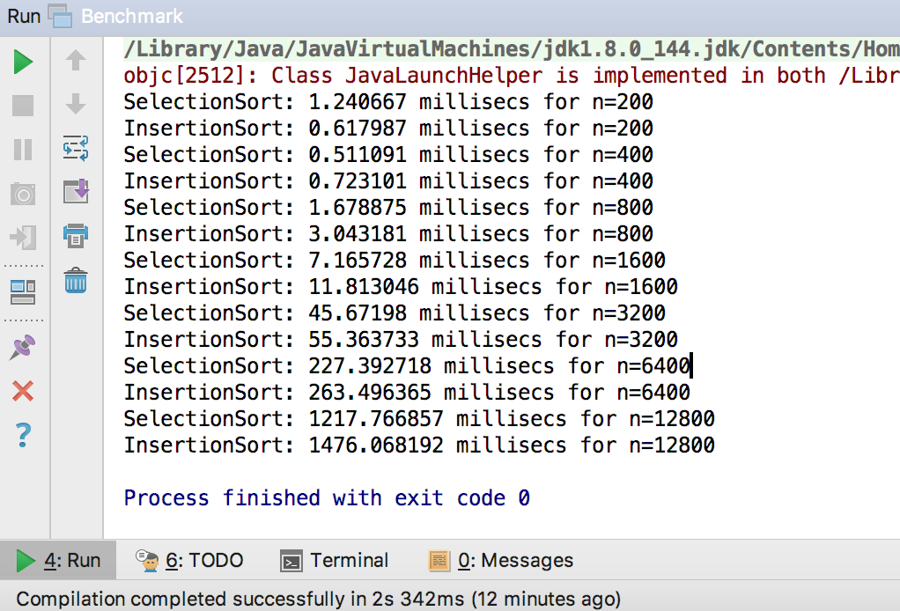

Test Resu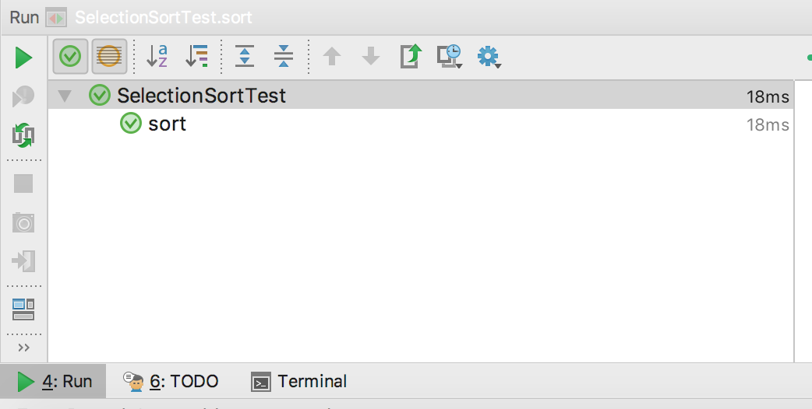lts：

